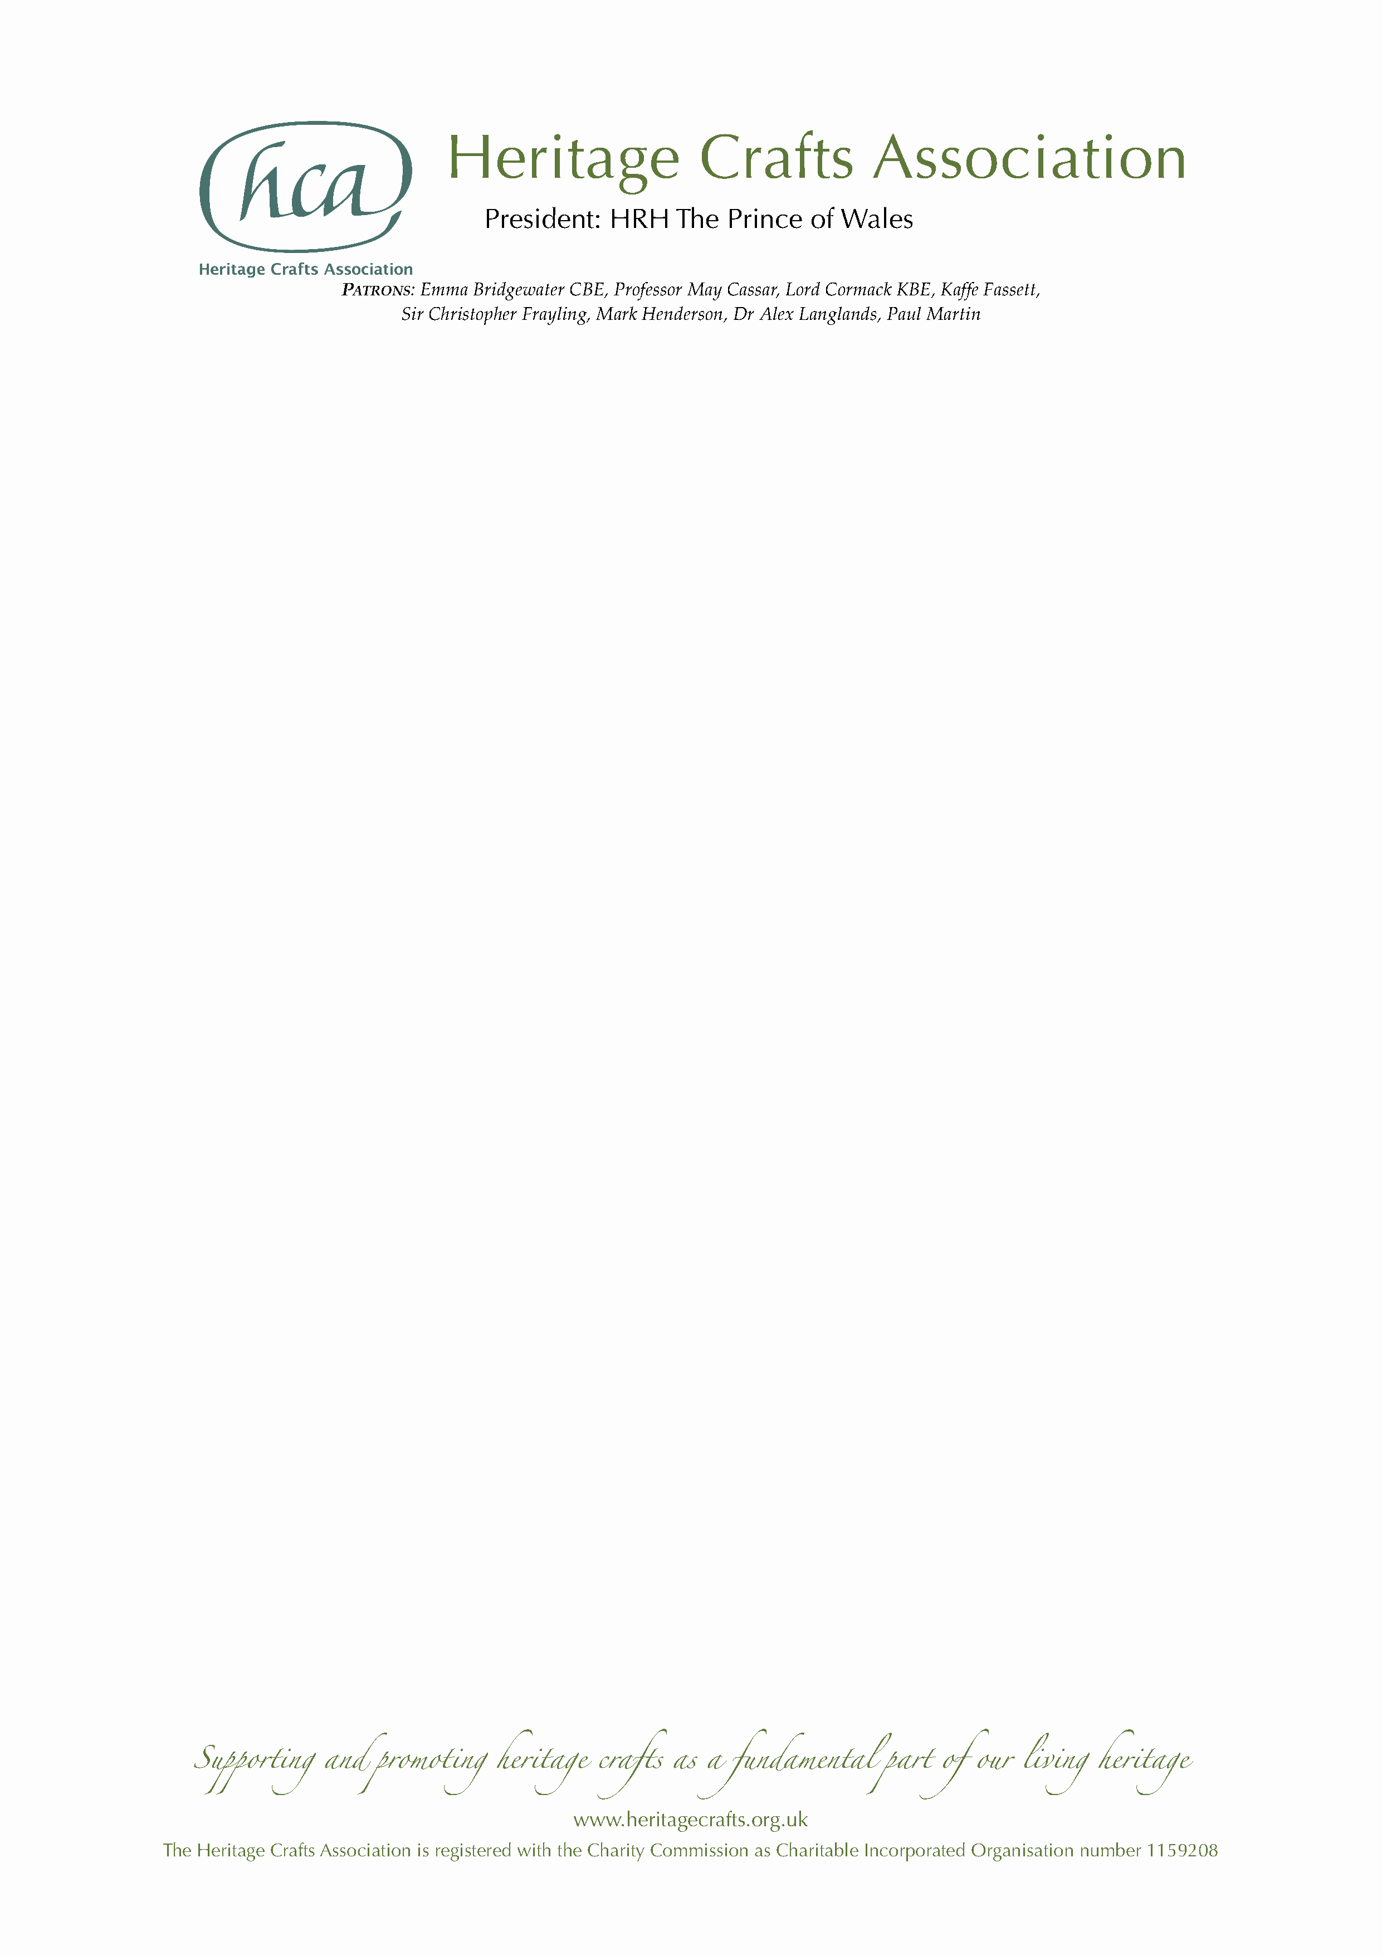

NEWS RELEASE

Friday 27 December 2019

MBE for Hertfordshire upholsterer Wendy Shorter-Blake

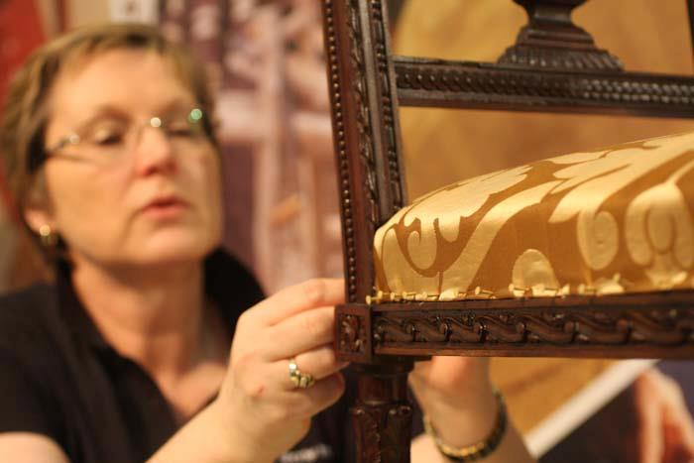
Wendy Shorter-Blake from Welwyn Garden City in Hertfordshire has been awarded an MBE in the Queen’s New Year Honours List 2020 for services to upholstery, in recognition of her unparalleled craftsmanship and tireless work in ensuring her skills are passed on to current and future generations.

Wendy was among three craftspeople nominated by the Heritage Crafts Association in this year’s New Year Honours, following 16 previously successful nominations since 2013. Earlier this year, the charitable organisation – which was set up ten years ago to support and champion traditional craft skills – published the latest edition of its groundbreaking HCA Red List of Endangered Crafts, the first report of its kind to rank endangered craft skills by the likelihood they will survive into the next generation.

Wendy is not only a highly skilled craftswoman herself but she has devoted her life to ensuring that the skills of upholstery are passed on. Over the last 13 years she has set up a multi-award winning training centre providing the very best possible standards of teaching based on her meticulous research of traditional techniques and the history of furniture.

Wendy was appointed Director of Training (a voluntary position) for the Association of Master Upholsters and Soft Furnishers (AMUSF) in 2008, putting her at the forefront of training provision and development of the Association’s qualification standards. In the last three years she has developed those standards into the current Diploma course, thus ensuring that hundreds of students can attain the highest level of qualification in the craft. She promoted a schools programme where sixth-formers from local schools were given the opportunity to train for an upholstery qualification, and personally sponsored one school leaver for more advanced training.

Wendy has also worked closely with the charity Fine Cell Work which offers craft training within prison and ongoing support and training for ex-offenders. In 2020 she will become the third female Master of the Worshipful Company of Upholders.

The two other craftspeople receiving MBEs in the New Year Honours are reverse glass sign artist David A Smith MBE from Torquay in Devon and chair caner Brian Crossley MBE from Tattenhall in Cheshire.

HCA Chair Patricia Lovett MBE said:

“While countries like Japan and Korea have National Living Treasures schemes to celebrate master craftspeople, the UK does not yet have an equivalent way of recognising our most highly skilled makers – and sadly we are one of only 15 of the 193 UNESCO member states yet to ratify the 2003 Convention on the Safeguarding of Intangible Heritage. We are therefore delighted that these talented individuals, who give so much of themselves to ensure that their crafts continue, have been recognised through the honours system, putting traditional craftspeople up there with other great luminaries of public life.”

The HCA encourages anyone who supports the continuation of traditional craft skills, whether or not they are makers themselves, to become HCA members via its website www.heritagecrafts.org.uk. The charity has set up an Endangered Crafts Fund to provide small grants to projects that increase the likelihood of endangered craft skills surviving into the next generation, and is currently seeking donations to save more of Britain’s most endangered crafts from oblivion – visit www.heritagecrafts.org.uk/ecf to find out more and to donate.

ENDS

Photo caption

Wendy Shorter-Blake demonstrating at the Ideal Home show.

Notes for Editors

- For more information about the Heritage Crafts Association contact Daniel Carpenter, HCA Communications Officer – daniel@heritagecrafts.org.uk.
- For additional photographs and quotes contact Wendy Shorter-Blake at wendyshorterinteriors@gmail.com.

About the Heritage Crafts Association

Founded in 2009, the Heritage Crafts Association (HCA) is a Charitable Incorporated Organisation (CIO), the advocacy body for traditional heritage crafts. Working in partnership with government and key agencies, it provides a focus for craftspeople, groups, societies and guilds, as well as individuals who care about the loss of traditional crafts skills, and works towards a healthy and sustainable framework for the future. Its aim is to support and promote heritage crafts as a fundamental part of our living heritage.

www.heritagecrafts.org.uk

About national honours for craftspeople

The Heritage Crafts Association is delighted to have successfully nominated a number of world-class craftspeople for national honours. To see the list of 16 previous recipients, visit www.heritagecrafts.org.uk/national-honours.

About the HCA Red List of Endangered Crafts

The HCA Red List of Endangered Crafts, created by the Heritage Crafts Association, was the first to rank traditional crafts in the UK by the likelihood they would survive the next generation. The 2019 edition of the Red List assessed 212 crafts to identify those which are at greatest risk of disappearing, of which four have been classified as extinct, 36 as critically endangered, 70 as endangered and 102 as currently viable.

The Red List shows that the craft knowledge, skills and practices that form an important part of our shared cultural heritage are – for a number of reasons – at risk of being lost. The HCA believes that these cultural assets are as important as unique heritage buildings and ancient beautiful landscapes and could provide future generations with fantastic opportunities to enrich their lives and the lives of others.

http://redlist.heritagecrafts.org.uk

