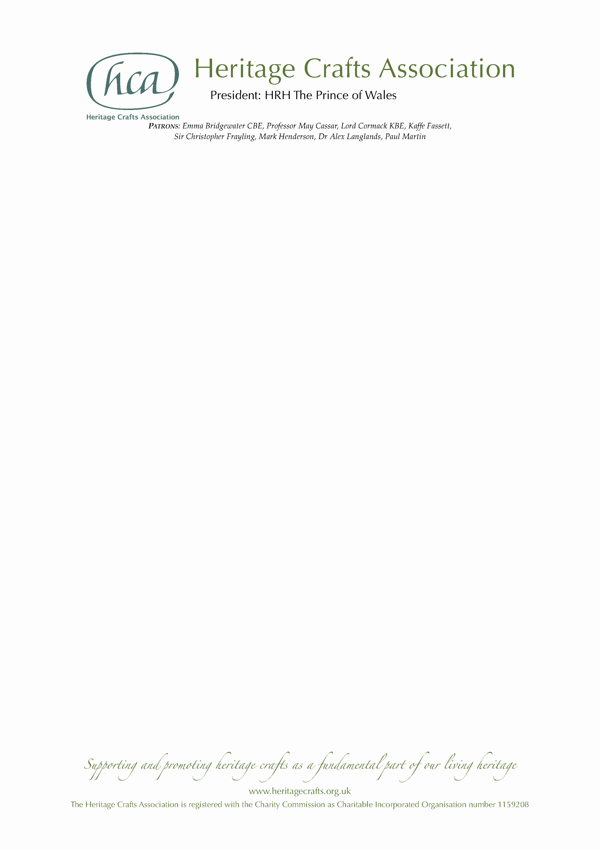

NEWS RELEASE

Friday 27 December 2019

MBE for Torquay glass sign artist David A Smith

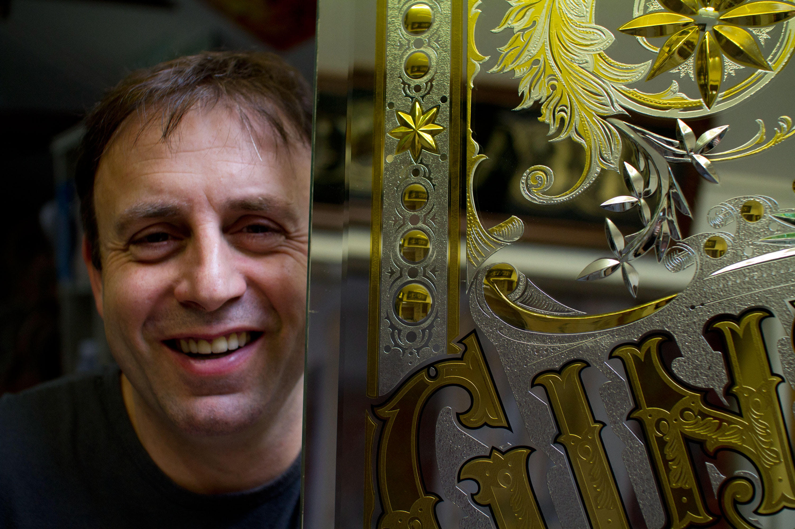
David A Smith from Torquay has been awarded an MBE in the Queen’s New Year Honours List 2020 for services to reverse glass ornamental artistry, in recognition of his unparalleled craftsmanship and tireless work in ensuring his skills are passed on to current and future generations.

David was among three craftspeople nominated by the Heritage Crafts Association in this year’s New Year Honours, following 16 previously successful nominations since 2013. Earlier this year, the charitable organisation – which was set up ten years ago to support and champion traditional craft skills – published the latest edition of its groundbreaking HCA Red List of Endangered Crafts, the first report of its kind to rank endangered craft skills by the likelihood they will survive into the next generation.

David is world-renowned for his high quality reverse glass lettering and artistry – which encompasses all the skills historically done by an array of craftspeople, including design, lettering, acid etching, brilliant cutting, silvering and angel gilding – having revived many of these skills from the point of extinction in the UK. He has had many high-profile commissions in the UK and abroad, including John Meyer, Sony Music, the Victoria & Albert Museum and Disney.

David has taught over 800 students (500 from abroad) and is the only practitioner able to teach such a broad range of skills, hence his craft being categorised as critically endangered in the HCA Red List of Endangered Crafts. Many hundreds of students have been able to benefit directly from the classes he teaches, both in his studio and in other countries. Many thousands more benefit from his regular online presence, where he shows examples of his work in process and gives pointers, advice and, most of all, provides encouragement to students and design enthusiasts worldwide.

David’s knowledge is extensive, and yet he still seeks out obscure processes from days gone by to enrich his craft and pass the information on to others, inspiring a new generation to the value of craftsmanship and artistry.

Mark Oatis, sign writer and founder of Letterheads, Las Vegas, said:

“In the present moment, David Smith is acknowledged by his peers to be the most proficient glass sign artist living. This a claim made without hyperbole, and one undisputed. His tactile precision and technical accuracy in the myriad processes employed in the cutting, etching, carving and decorating of plate glass is unparalleled… This achievement alone is worthy of celebration, but even greater still is David's sublime sense of design; his authoritative, playful and utterly original dance with letters.”

The two other craftspeople receiving MBEs in the New Year Honours are upholsterer Wendy Shorter-Blake MBE from Welwyn Garden City in Hertfordshire and chair caner Brian Crossley MBE from Tattenhall in Cheshire.

HCA Chair Patricia Lovett MBE said:

“While countries like Japan and Korea have National Living Treasures schemes to celebrate master craftspeople, the UK does not yet have an equivalent way of recognising our most highly skilled makers – and sadly we are one of only 15 of the 193 UNESCO member states yet to ratify the 2003 Convention on the Safeguarding of Intangible Heritage. We are therefore delighted that these talented individuals, who give so much of themselves to ensure that their crafts continue, have been recognised through the honours system, putting traditional craftspeople up there with other great luminaries of public life.”

The HCA encourages anyone who supports the continuation of traditional craft skills, whether or not they are makers themselves, to become HCA members via its website www.heritagecrafts.org.uk. The charity has set up an Endangered Crafts Fund to provide small grants to projects that increase the likelihood of endangered craft skills surviving into the next generation, and is currently seeking donations to save more of Britain’s most endangered crafts from oblivion – visit www.heritagecrafts.org.uk/ecf to find out more and to donate.

ENDS

Photo caption

David A Smith with one of his creations (photo by David A Smith).

Notes for Editors

- For more information about the Heritage Crafts Association contact Daniel Carpenter, HCA Communications Officer – daniel@heritagecrafts.org.uk.
- For additional photographs and quotes contact David A Smith at davidadriansmith@icloud.com.

About the Heritage Crafts Association

Founded in 2009, the Heritage Crafts Association (HCA) is a Charitable Incorporated Organisation (CIO), the advocacy body for traditional heritage crafts. Working in partnership with government and key agencies, it provides a focus for craftspeople, groups, societies and guilds, as well as individuals who care about the loss of traditional crafts skills, and works towards a healthy and sustainable framework for the future. Its aim is to support and promote heritage crafts as a fundamental part of our living heritage.

www.heritagecrafts.org.uk

About national honours for craftspeople

The Heritage Crafts Association is delighted to have successfully nominated a number of world-class craftspeople for national honours. To see the list of 16 previous recipients, visit www.heritagecrafts.org.uk/national-honours.

About the HCA Red List of Endangered Crafts

The HCA Red List of Endangered Crafts, created by the Heritage Crafts Association, was the first to rank traditional crafts in the UK by the likelihood they would survive the next generation. The 2019 edition of the Red List assessed 212 crafts to identify those which are at greatest risk of disappearing, of which four have been classified as extinct, 36 as critically endangered, 70 as endangered and 102 as currently viable.

The Red List shows that the craft knowledge, skills and practices that form an important part of our shared cultural heritage are – for a number of reasons – at risk of being lost. The HCA believes that these cultural assets are as important as unique heritage buildings and ancient beautiful landscapes and could provide future generations with fantastic opportunities to enrich their lives and the lives of others.

http://redlist.heritagecrafts.org.uk

